KORjuice.com

Taglines:

“The KOR of an apple, The KOR of your Health, The KOR of a cause”

“What does KOR mean to you”?

“Cold Pressed, Fresh, Raw, Vegan”

**Main Points on Landing/Main Page-** Main page will be simple with the following 3 Main points (linked to additional content). I would also like to promote the Kickstarter/ Kickstarter Video / FB and Twitter somehow.

* **Cold Pressed Juicing (Image)**

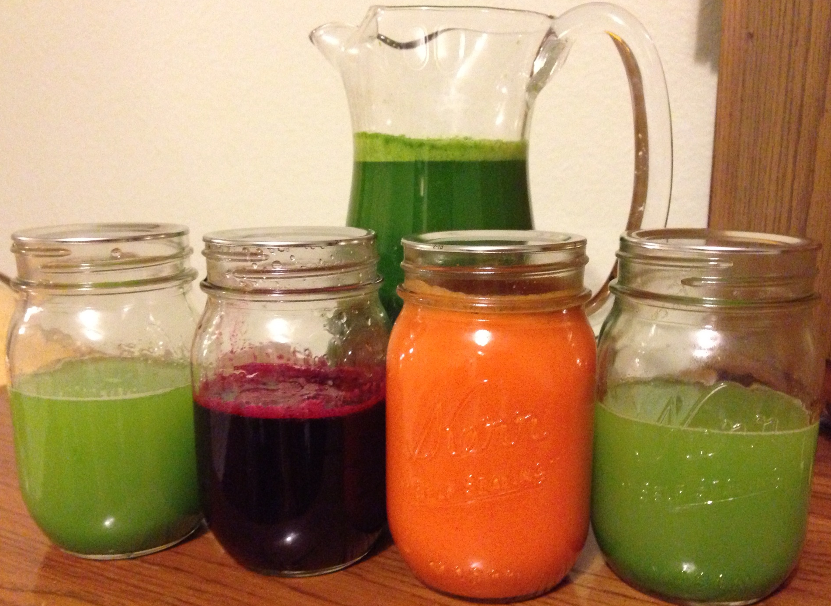

* + Keeps 3-5 times the amount of nutrients compared to traditional juicing methods
* **Our Vision (Image)**

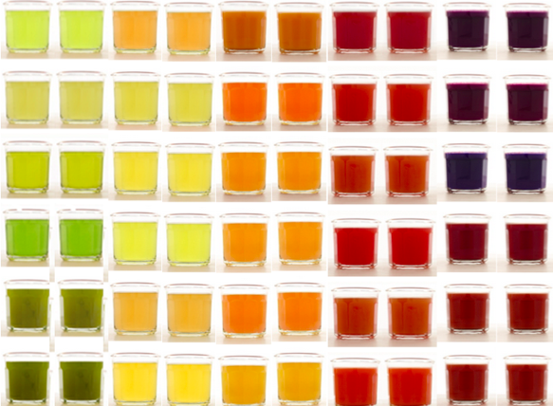

* + Customized Juices –Unlimited Menu
  + Customized Cleanses –By Health Benefit
  + Affordable Juicing
* **KOR Fight vs World Hunger (Image)**

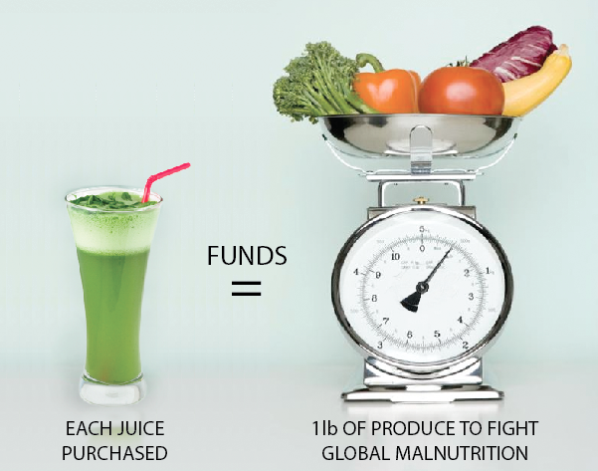

* + Each Juice purchased = Funds 1 lb of Produce to fight Global Malnutrition

Note: The The Sub- Bullet Points will be content shown when Hovering on link)

**Links in Header: (Each of these links will link to a respective page that has more content**

* **The “Kor” of Our Vision**

Our Concept

* **Customized Juices** **– Unlimited Menu**

Craft your own concoction!

While a recipe wall is used to give you inspiration, you are the ultimate decision maker at the KOR of your juice.

* **Customized Cleanses**

Everyone has a different reason to cleanse!

We will offer 1/2/3 day cleanses based on your desired health benefit

* **AFFORDABLE PRICING**

All juices are priced based on weight of produce!

In the mood for a hearty cold press juice? Only want a small serving to kick off your day? No problem!

* **PICK IT YOURSELF (PIY)**

From Oranges to Kale to Dragon Fruit, you pick the ingredients & we do the rest!

Customize your juice to your hearts' content

* **The Fight**

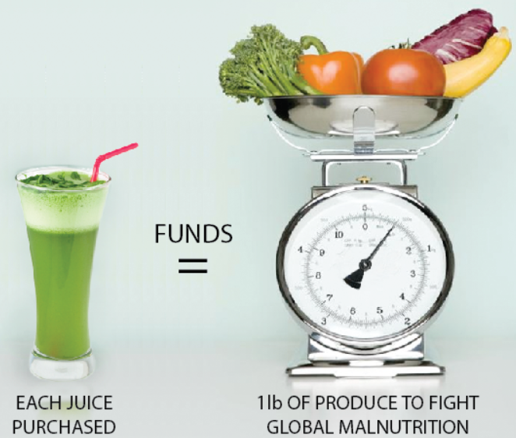

* I will add some additional written content as well.
* **Cold Press Juicing**

Cold-Press Juicing

*verb*

1. The act of making juice through a near decade old technique that extracts pure juice from fresh, raw fruits and veggies using a hydraulic press that applies a tremendous amount of pressure to extract the nectar directly from the pulp.

2. The Cold Press juice extraction technique uses no heat, ensuring the vital enzymes, nutrients and minerals of the fruits and vegetables stay intact and aren’t cooked away.

Cold-Press Juicing is an upcoming trend. Chances are, you have seen or heard of a cold-press juice bar in your neighborhood. What used to be a hidden secret among advent juicers has slowly become more mainstream.

Why? Because people have caught on that cold-press juicing is a great natural way to provide your body with essential nutrients and vitamins your body need. Something Jamba Juice can’t provide with its unnatural sugars, syrups and preservatives! Above all else, cold-press juicing is incredibly *healthy*.

If you haven't heard of this juicing trend, check out this New York Times Article: [Juice Bar Brawl](http://www.nytimes.com/2013/04/17/dining/the-rush-toward-cold-pressed-juices.html?pagewanted=all)

* **Juicers Thoughts**
  + “Great Concept! It really allows me to put exactly what I want in my Juice”
  + “I am always a bit skeptical on what exactly goes into my Juice at current Juice Bars, I like your idea of being able to physically pick the fruits and veggies and hand it over to get juiced”
  + “I love the idea of choosing my own produce and then watching my juice being made Fresh!”
  + “I like the idea of being able to test unlimited recipes without having to go through all the trouble of buying it, washing it, juicing it!”
  + “I like the fact there are ethnic fruits/ veggies! Juice Bars don’t really have that option”
  + “Sometimes I go to a Juice Bar and they have a Juice on their Menu, and I want to switch out an ingredient, but they won’t let me!”
  + “When I go to some Juice Bars, I always want to ‘mix and match’ a few recipes on their menu, but they won’t let me!”
* <script type="text/javascript" src="https://aytm.com/pw/js/pw_share.js?t=rb33fb3"></script> <div id="aytm-pw-rb33fb3" rel="https://aytm.com/rb33fb3?ifr=t&content_width=542&w_bg=f" style="width:542px;"> <div id="aytm-pw-rb33fb3-loader" style="position:relative;display:none;clear:both;width:542px;height:260px;padding:40px 0 0;margin:0 auto;text-align:center;background:transparent url(https://aytm.com/images/pw/selp.png) no-repeat scroll center center;"> <img src="https://aytm.com/images/pw/sel.png" alt="AYTM" style="margin:0 auto;padding:0;border:0 none;"/> </div> <div style="display:block;color:#555555;font-family:Calibri,Trebuchet MS;font-size:13px;line-height:15px;padding:0px 10px 10px;"> Create stunning online surveys free of charge. <a href="https://aytm.com/" target="_blank" style="color:#1B75BB;font-family:Calibri,Trebuchet MS;font-size:13px;line-height:15px;">AYTM Market Research</a> </div> </div>
* **KOR Vision**

Our Story is very simple.

We are a group of aspiring cold-press juicers who want to revolutionize the world of juicing. As excited as we were to see the cold-press juicing trend starting to pick up steam, we found current juice bars have a common theme:

1) Juices are Expensive

2) Juices can’t be customized

For us, this was an issue. How could we revolutionize the world of juicing if the juice is not affordable and customers can’t choose their own ingredients? This is where KOR Juice Bar comes in to the picture. We are simply a juice bar that seeks to address these two concerns among the Juicing Community. We are seeking to be the very first juice bar that allows YOU as the customer to pick the ingredients in your Juice. After all, it is your Juice!

* **Photos**
  + A random page of pictures of produce/ juicing/ juices, etc…
* **Location**
  + We plan to open our first store in Southern California with hopes to expand to where you the Juicers want us!